CRICKET PLAYER PERFORMANCE TRACKING Application : CRICKSTATS
Project Documentation



TEAM MEMBERS:

Team ID : SWTID-2026-2251
Team Size : 4
Team Leader : MANISH A
Team member : MANIKANDAN S
Team member : MANISH P
Team member : MANIVANNAN A

NAN MUDHALVAN DEPARTMENT- STAFF
V. SAKTHIVEL - HOD
C. KUMAR - TUTIOR

PROJECT OVERVIEW CONCLUSION :-
- Introduction
- Problem Statement
- Solution
- Requirement Analysis
- System Design
- Development
- Testing
- Results
- Conclusion

Introduction

CRICKSTATS is a Salesforce-based application developed to track, manage, and analyze cricket players' performance on a match-by-match basis. The system is designed to provide a centralized and structured platform for recording player statistics such as runs scored, wickets taken, and strike rate. By leveraging Salesforce features like custom objects, relationships, formula fields, automation tools, reports, and dashboards, the application delivers accurate performance insights in a visual and interactive format. CRICKSTATS helps coaches, analysts, and administrators evaluate player consistency, compare performances, and make data-driven strategic decisions. Cricket teams require detailed and accurate data analysis.

Purpose :

The main purpose of this project is: To digitize player performance records To improve accuracy and accessibility of cricket statistics To provide real-time analytics To support player development and team planning To automate data management using Salesforce

Problem Statement
The existing system for tracking cricket performance faces several challenges:

- No centralized data management system
- Manual calculation errors in performance metrics
- Difficulty in analyzing long-term performance trends
- Lack of automation alerts for performance issues
- Time-consuming report generation process

These limitations reduce efficiency, accuracy, and strategic decision-making capabilities.
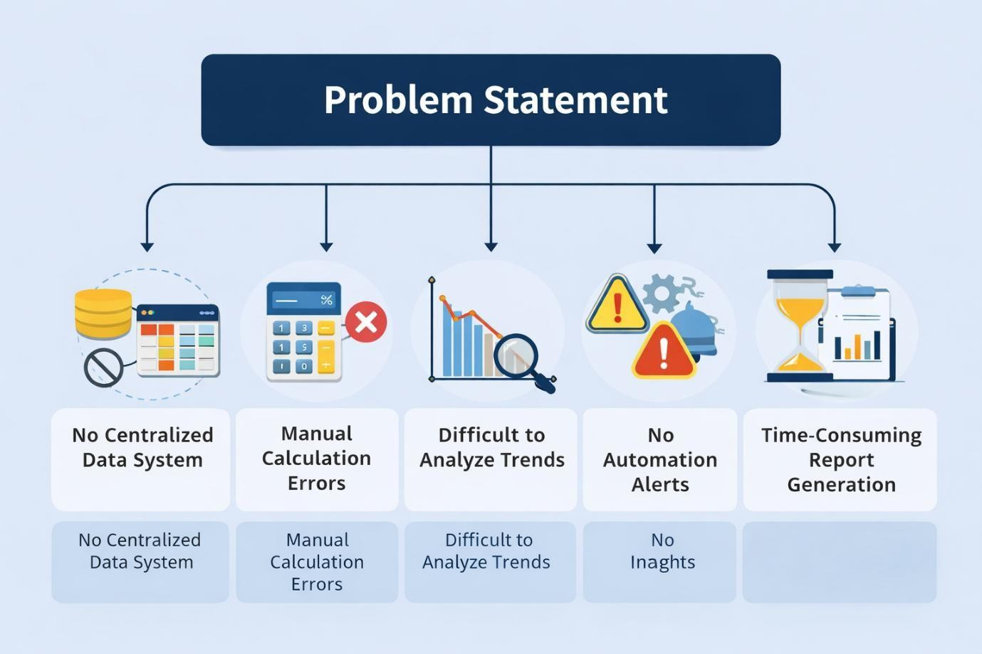

Proposed Solution
To address the identified challenges, the proposed solution is to develop a Salesforce-based application called CRICKSTATS.

The system is designed to:

  - Store player and match data in a centralized database
  - Automatically calculate performance metrics such as strike rate and averages
  - Generate dynamic reports and interactive dashboards
  - Provide analytical insights to support data-driven decision-making

By leveraging Salesforce features like custom objects, formula fields, automation flows, and dashboards, the application ensures accuracy, efficiency, and scalability.
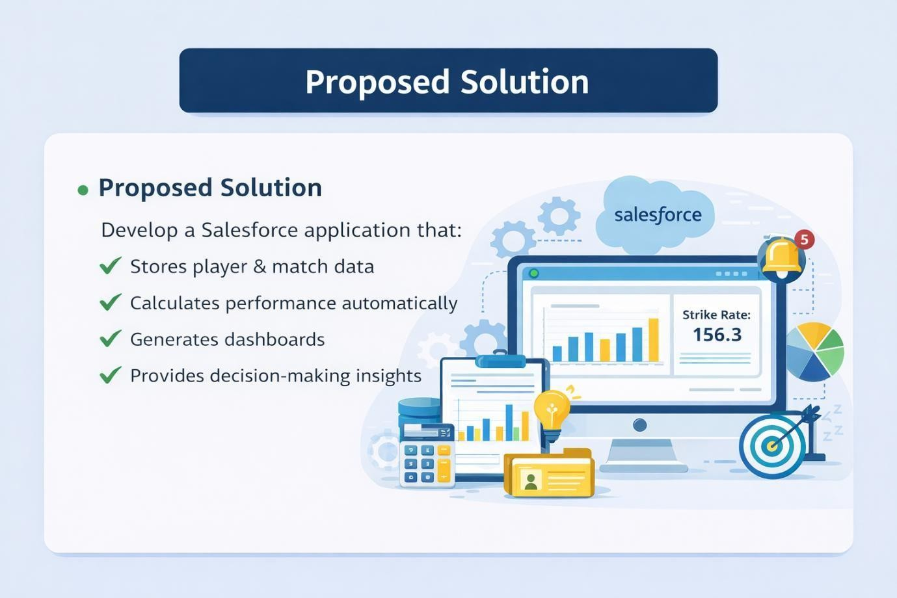

Objectives
The main objectives of the CRICKSTATS application are:

  - To track and monitor player performance on a match-by-match basis
  - To automate statistical calculations such as strike rate and averages
  - To provide visual dashboards for clear performance analysis
  - To improve decision-making through structured and data-driven insights These objectives ensure efficiency, accuracy, and better performance evaluation.

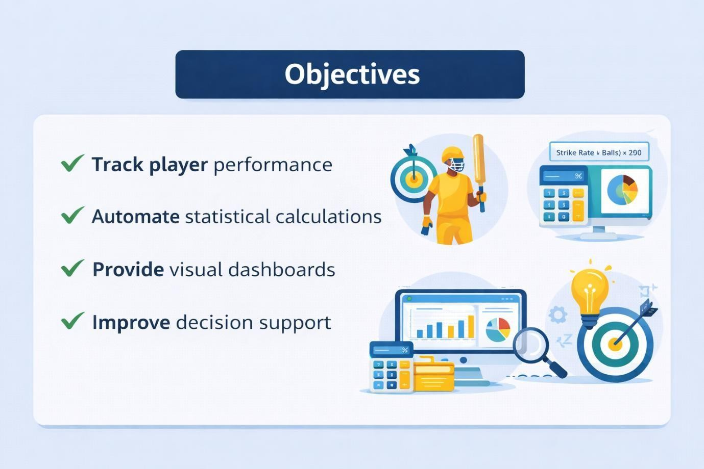

System Overview (Professional Version)
CRICKSTATS is developed on the Salesforce Lightning Platform using core CRM and automation features to ensure structured data management and intelligent analytics.

The system is built using:

Custom Objects

Custom objects are used to store structured data such as Player, Match, and Performance details.

Relationships

Relationships (Lookup / Master-Detail) are used to connect objects, enabling one-to-many data associations like one Player having multiple Performance records.

Formula Fields

Formula fields automatically calculate values such as Strike Rate using predefined logic without manual input.

Reports & Dashboards

Reports are used to organize and filter data, while dashboards visually represent performance metrics using charts and graphs.

Automation (Flow)

Salesforce Flow is used to automate processes like generating alerts and updating records based on performance conditions.
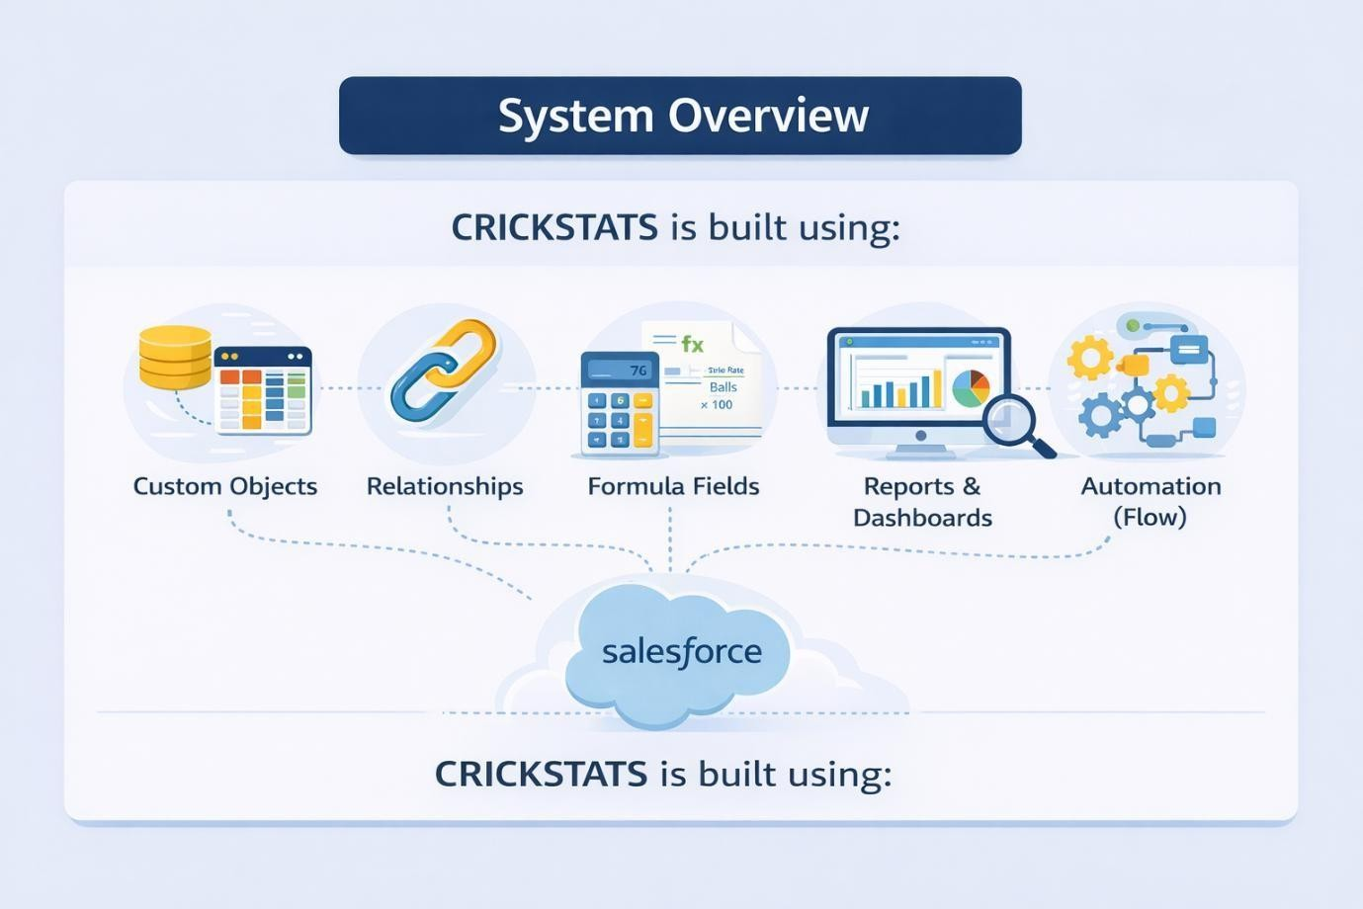

Proposed Solution
To address the identified challenges, the proposed solution is to develop a Salesforce-based application called CRICKSTATS.

The system is designed to:

  - Store player and match data in a centralized database
  - Automatically calculate performance metrics such as strike rate and averages
  - Generate dynamic reports and interactive dashboards
  - Provide analytical insights to support data-driven decision-making

By leveraging Salesforce features like custom objects, formula fields, automation flows, and dashboards, the application ensures accuracy, efficiency, and scalability.

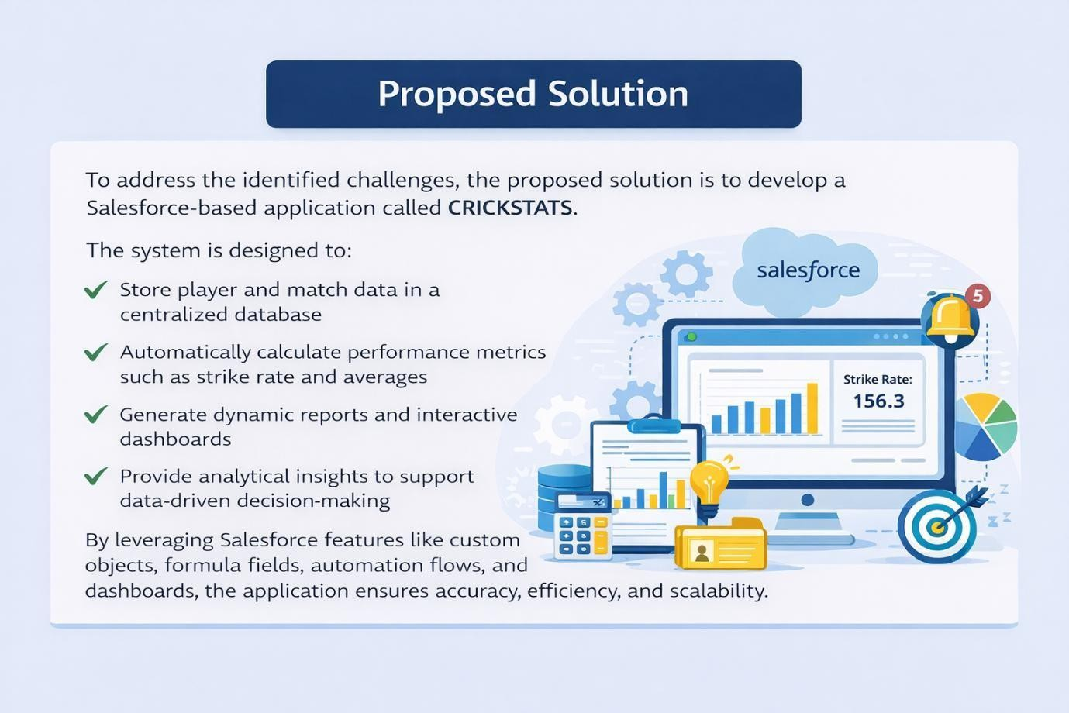

3.2 Solution Requirements

FR No | Requirement
FR-1 | Player Registration
FR-2 | Match Performance Entry
FR-3 | Dashboard Generation
FR-4 | Report Creation
FR-5 | Flow Automation

Functional Requirements
Description

FR-1: Player Registration
The system shall allow administrators to register new players with necessary details such as name, role, team, and other relevant information.

FR-2: Match Performance Entry
The system shall allow authorized users to enter player performance data for each match, including runs scored, balls faced, wickets taken, and other statistics.

FR-3: Dashboard Generation
The system shall generate visual dashboards to display performance metrics in graphical format.

FR-4: Report Creation
The system shall allow users to generate customized reports based on filters such as player name, match date, and team.

FR-5: Flow Automation
The system shall implement Salesforce Flow automation to automatically calculate performance metrics and trigger alerts based on predefined conditions.

Non-Functional Requirements (NFRs) –
CRICKSTATS

NFR-1: Usability
The system shall be easy to understand and use by coaches, managers, analysts, and administrators without requiring technical training.

Requirements:

- Simple and intuitive user interface
- Clear navigation menus
- Easy-to-read dashboards
- Minimal learning curve

Example:

A new coach should be able to log in, enter match data, and view player reports within a few minutes without special training.

The Salesforce Lightning interface provides drag-and-drop dashboards and user-friendly forms.

NFR-2: Security
The system shall protect sensitive player data from unauthorized access.

Requirements:

- Role-based access control
- Secure authentication
- Encrypted data storage
- Regular data backups

Example:

- Coaches can view player statistics
- Managers can edit records
- Analysts can generate reports
- Only administrators can modify system settings

Salesforce Profiles and Permission Sets restrict access to confidential information.

NFR-3: Reliability
The system shall function correctly without failure and ensure accurate data storage.

Requirements:

- No data loss
- Automatic backups
- Proper error handling
- System stability

Example:

If a manager enters match statistics and loses internet connection, the data should be saved automatically once reconnected.

Salesforce cloud backup ensures recovery in case of system failure.

NFR-4: Performance
The system shall respond quickly and handle large volumes of data efficiently.

Requirements:

- Fast page loading
- Quick report generation
- Smooth dashboard rendering
- Minimal response time

Example:

When an analyst generates a performance report for more than 100 players, the report should load within 2–3 seconds.

Optimized Salesforce queries and caching improve response speed.

NFR-5: Availability
The system shall be accessible whenever users require access.

Requirements:

- 24/7 system availability
- Minimal downtime
- Cloud-based access
- Disaster recovery mechanisms

Example:

Coaches should be able to access CRICKSTATS during tournaments at night or on weekends.

Salesforce provides high uptime with cloud hosting.

NFR-6: Scalability
The system shall support increasing numbers of users, players, and records.

Requirements:

- Handle growing datasets
- Support more teams and leagues
- Expand storage capacity
- Maintain performance under high load

Example:

If CRICKSTATS expands from one team to 50 teams, the system should continue to perform smoothly.

Salesforce cloud infrastructure automatically scales storage and processing capacity.

PROJECT DESIGN PHASE

The CRICKSTATS system effectively addresses the key challenges faced in traditional cricket performance management. Earlier, most player and match data were maintained using manual records, which were time-consuming and prone to errors. This issue has been resolved by implementing an automated system through Salesforce, which ensures accurate and efficient data entry and management. The problem of data loss, caused by improper

storage and lack of backups, is overcome by using secure cloud storage that safely stores all information and allows easy retrieval. Poor analysis of player performance, due to scattered and unorganized data, is addressed through interactive dashboards that present clear visual insights and reports. Additionally, delays in accessing performance information and generating reports are eliminated by providing real-time reporting features, enabling users to make faster and more informed decisions. Thus, CRICKSTATS successfully bridges the gap between existing problems and modern technological solutions.

Proposed Solution

Description
CRICKSTATS is a Salesforce-based application designed to provide a structured and automated system for managing cricket player performance data.

The solution includes the following components:

- Custom Objects (Player, Match Performance)
- Master-Detail Relationships
- Roll-Up Summary Fields
- Salesforce Lightning Application
- Automated Flows
- Interactive Dashboards

These components work together to ensure centralized data management, automation, and performance analytics.

Key Features
The CRICKSTATS application provides the following key features:

- Centralized database for storing player and match data
- Live statistical calculations using formula and roll-up fields
- Secure access through role-based permissions
- Scalable cloud-based design
- Easy report generation and dashboard visualization

4.3 Solution Architecture
CRICKSTATS follows a layered architecture approach to ensure separation of concerns and efficient system management.

Architecture Layers
- Presentation Layer (Lightning UI)

This layer represents the user interface built using Salesforce Lightning.
It allows users such as coaches, managers, and analysts to interact with the system through forms, dashboards, and navigation menus.

- Application Layer (Flows and Business Logic)

This layer handles system logic and automation.
It includes Salesforce Flows and validation rules that automate processes such as performance calculation and alert generation.

- Data Layer (Custom Objects)

This layer manages data storage using custom objects such as:

  - Player
  - Match
  - Performance

Relationships and roll-up summary fields ensure accurate and structured data management.

- Analytics Layer (Reports and Dashboards)

This layer provides analytical insights through:

  - Reports
  - Dashboards
  - Charts and Graphs

It helps stakeholders analyze performance trends and make data-driven decisions.

Project Flow

Milestone 1 : Creation of developer account Milestone 2 : Object Creation
Milestone 3 : Tabs

Milestone 4 : The Lightning App Milestone 5 : Fields & Relationships Milestone 6 : Roll-up Summary Milestone 7 : Flows
Milestone 1 : Creation of developer account

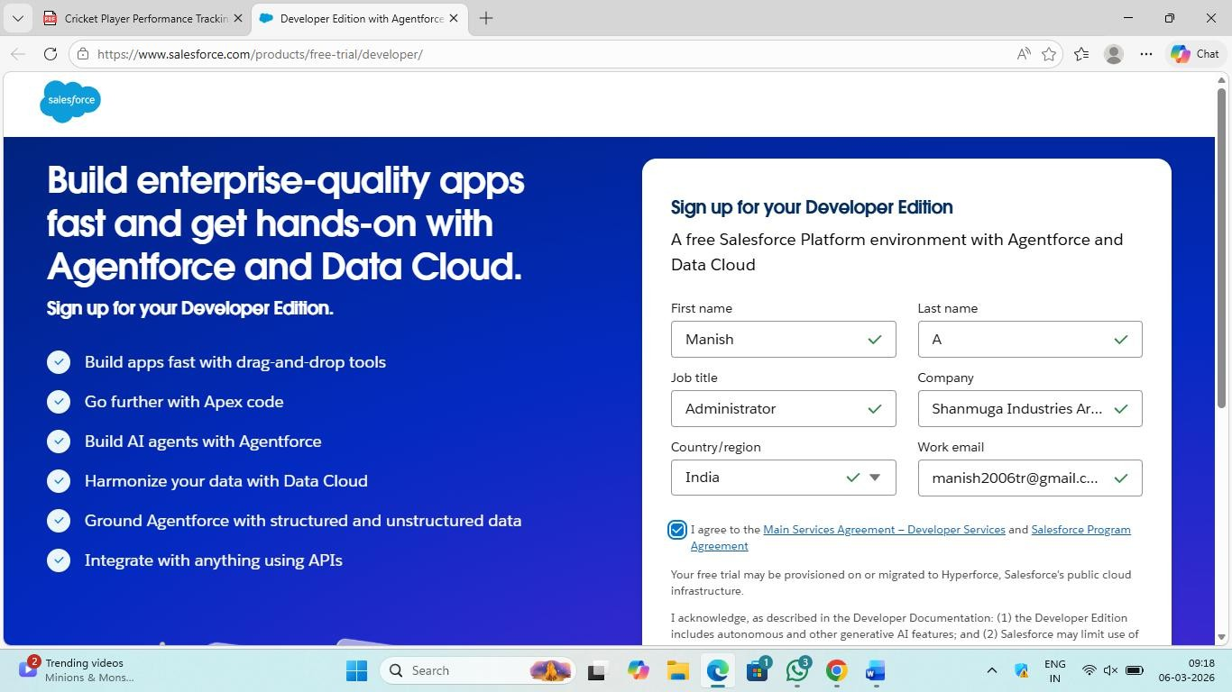

The first milestone in the CRICKSTATS project was the creation of a Salesforce Developer Account.

A Salesforce Developer Account provides a free cloud-based environment where custom applications can be designed, developed, tested, and deployed without affecting live production systems.

This step was essential to:

  - Access the Salesforce Lightning Platform
  - Create custom objects and fields
  - Configure relationships
  - Implement automation using Flow
  - Generate reports and dashboards

The developer environment served as the foundation for building and testing the CRICKSTATS application before final deployment.

Milestone 2 : Object Creation

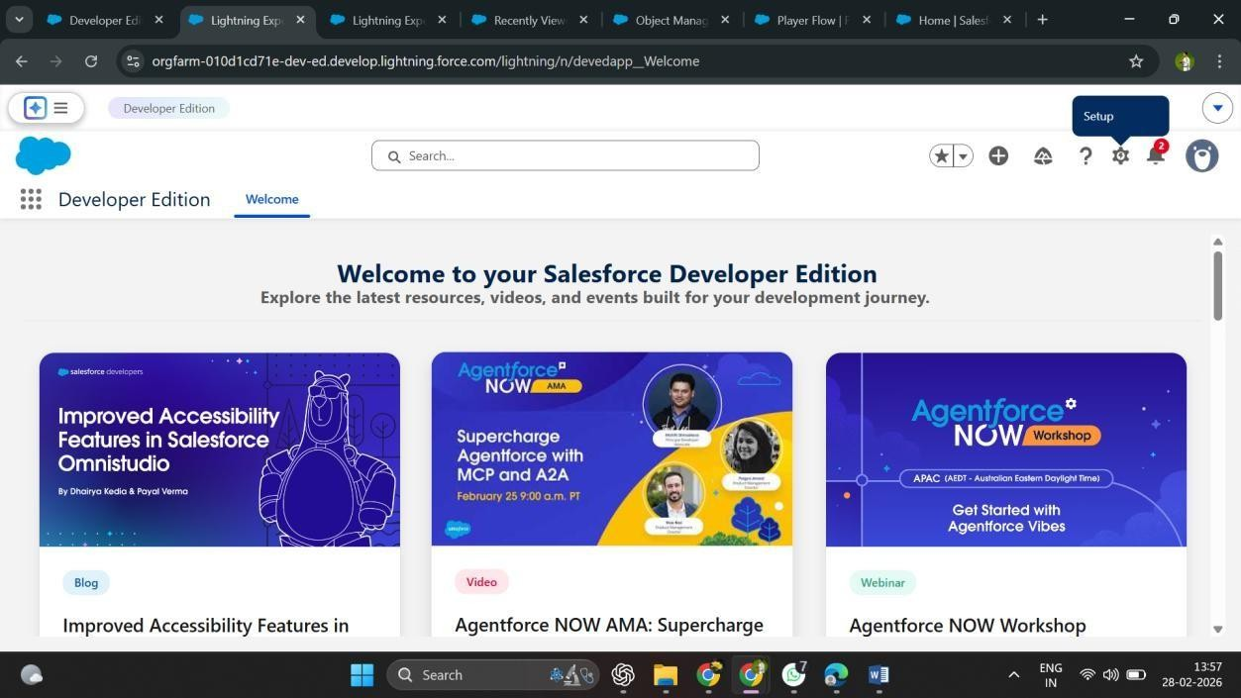

The second milestone of the CRICKSTATS project involved creating custom objects to structure and manage cricket performance data within Salesforce.

In Salesforce, an object acts as a database table that stores specific types of information. Custom objects were created to store domain-specific data related to cricket performance tracking.

The following custom objects were created:

- Player Object

This object stores player-related information such as:

  - Player Name
  - Role (Batsman, Bowler, All-rounder)
  - Team
  - Date of Birth

- Match Object

This object stores match-related details such as:

  - Match ID
  - Match Date
  - Opponent Team
  - Venue

- Performance Object

This object stores match-wise player performance data such as:

  - Runs Scored
  - Balls Faced
  - Wickets Taken
  - Strike Rate

The creation of these objects established a structured data model for the CRICKSTATS application. It ensured that all player and match information could be stored, retrieved, and analyzed efficiently.

This milestone laid the foundation for implementing relationships, automation, and reporting features in later stages of the project.

Milestone 3 : Tabs

The third milestone of the CRICKSTATS project involved creating custom tabs for each custom object in Salesforce.

In Salesforce, a tab provides a user interface entry point to access object records. Creating tabs allows users to easily view, create, and manage data stored in custom objects.

Tabs were created for the following objects:

  - Player
  - Match
  - Performance

Each tab was configured with appropriate labels, icons, and visibility settings to ensure easy navigation within the Lightning interface.

The purpose of creating tabs was to:

  - Improve user accessibility
  - Enable quick data entry
  - Provide structured navigation
  - Enhance overall user experience

By organizing objects into tabs, the system became more intuitive and user-friendly, allowing coaches, managers, and analysts to efficiently interact with the application.

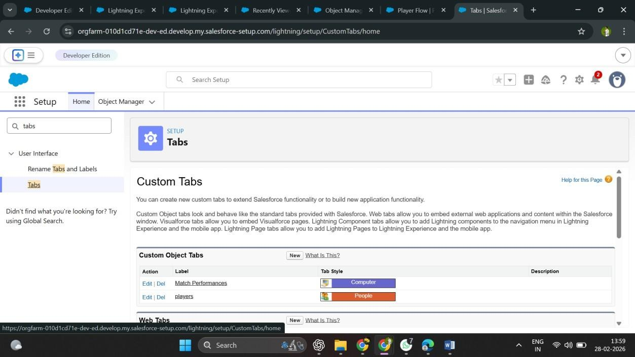

Milestone 4: The Lightning App

Explanation
In this milestone, a custom Lightning App named CRICKSTATS was created in Salesforce.

A Lightning App provides a centralized workspace that combines related tabs, objects, dashboards, and reports into one unified interface.

The Lightning App included:

  - Player Tab
  - Match Tab
  - Performance Tab
  - Reports
  - Dashboards

This milestone improved usability by organizing all project components into a single, structured navigation menu. It ensured that users such as coaches, managers, and analysts could easily access all features without switching between different areas of Salesforce.

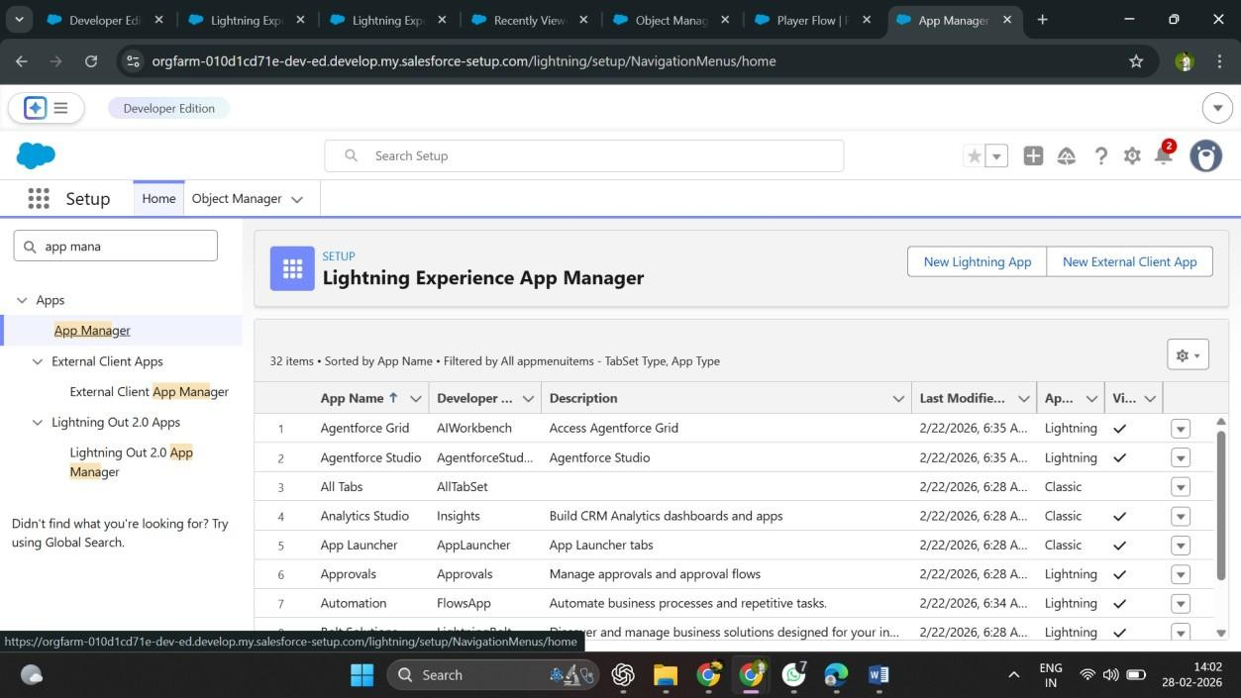

Step 1: App Details and Branding
While creating the Lightning App, the following details were configured:

  - App Name: CRICKSTATS
  - Developer Name: Auto-populated by Salesforce
  - App Image: Optional (Can be added for branding purposes)
  - Primary Color (Hex Code): Default color selected After entering the required details, click Next to proceed.

Step 2: App Options
The following application settings were configured:

  - Navigation Style: Standard Navigation
  - Setup Experience: Setup
  - Supported Form Factors: Desktop and Phone

These settings ensure that the application is accessible across devices and follows standard Salesforce navigation behavior.

After configuring these options, click Next.

Step 3: Utility Items (Font Size 13 – Bold)
  - Utility Bar Alignment: Default

No additional utilities were added at this stage. Click Next to continue.

Step 4: Navigation Items (Font Size 13 – Bold)
The following navigation items were added to the Lightning App:

  - Players (Custom Object)
  - Match Performances (Custom Object)
  - Reports (Standard Object)
  - Dashboards (Standard Object)

These items were selected to ensure that users can easily access core application components from the navigation menu.

Milestone 5: Fields & Relationships
In this stage, custom fields were created within each object to store specific data, and relationships were established between objects.

Fields Created

Examples include:

  - Runs Scored
  - Balls Faced
  - Wickets Taken
  - Strike Rate (Formula Field)
  - Match Date
  - Player Role

Relationships Implemented

Master-Detail Relationships were created to connect:

  - Player → Performance
  - Match → Performance This means:
  - One Player can have multiple Performance records.
  - One Match can have multiple Performance records.

These relationships ensure structured data storage and enable advanced features like roll-up summaries and reporting.

This milestone established a strong data model for CRICKSTATS.

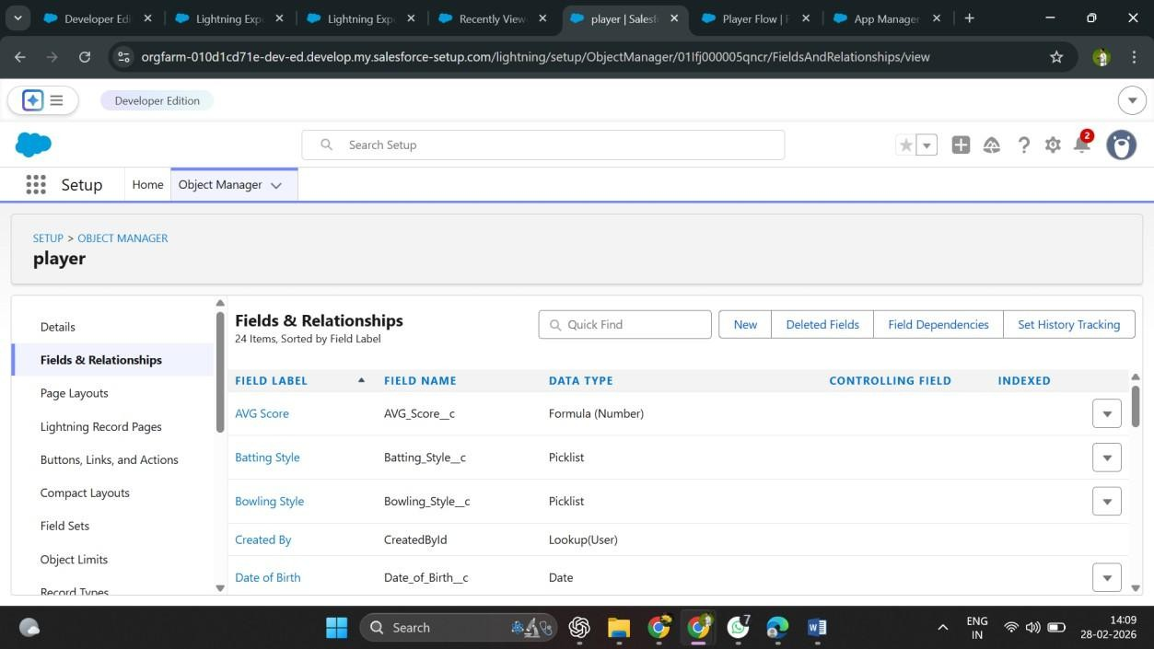

Milestone 6: Roll-Up Summary

Explanation
Roll-up summary fields were implemented to automatically calculate aggregated values from related records.

For example:

  - Total Runs scored by a Player
  - Total Wickets taken
  - Average Performance metrics

Roll-up summaries work only in Master-Detail relationships and automatically update parent records whenever child records are modified.

This milestone eliminated manual calculations and improved data accuracy.

Step 1: Open Setup
Log in to your Salesforce organization.
Click the Gear icon located at the top-right corner of the screen and select Setup to open the Setup page.

Step 2: Navigate to Object Manager
In the Setup page, click on the Object Manager tab.

If the Object Manager tab is not visible, enter Object Manager in the Quick Find box to locate it quickly.

Step 3: Select the Player Object
From the Object Manager page, use the Quick Find box to search for the custom object named Player.

Click on the Player object to open its configuration page.

Step 4: Open Fields & Relationships
From the left sidebar menu, click on Fields & Relationships.

You will notice that some fields are already present. These are standard fields automatically created by Salesforce.

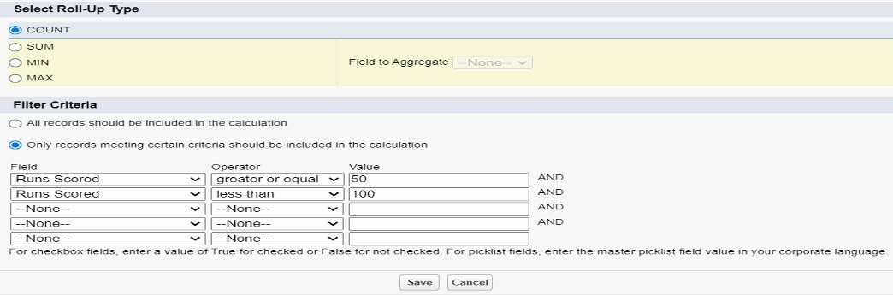

Step 5: Create a New Custom Field
Click on the New button to create a new custom field.

Tip: Before creating a new field, perform a quick search to ensure that a similar field does not already exist.

Step 6: Choose Data Type
Select the Text data type and click Next.

Choosing the appropriate data type ensures that the field input is properly formatted and validated according to the expected data

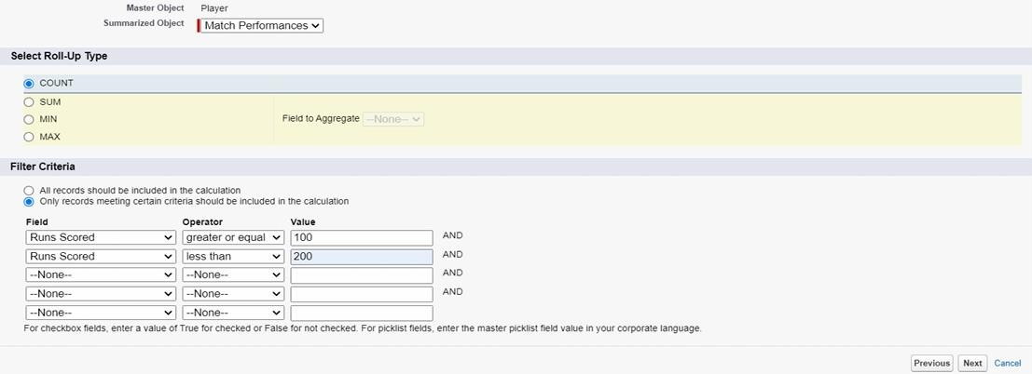

Milestone 7 : Flows
Milestone 7 focuses on implementing automation using Salesforce Flow Builder.

Salesforce Flow is a powerful automation tool that allows developers to create logic-driven processes without writing code. It helps automate tasks based on specific conditions and triggers.

In the CRICKSTATS application, Flows were implemented to enhance system intelligence and reduce manual effort.

Purpose of Implementing Flows
The main objectives of using Flows in CRICKSTATS were:

  - To automate performance calculations
  - To trigger alerts based on predefined conditions
  - To automatically update related records
  - To improve operational efficiency

Types of Flow Used
A Record-Triggered Flow was created to run automatically when a record is created or updated in the Performance object.

Automation Implemented
The following automation processes were configured:

  - Automatic calculation of strike rate
  - Alert generation when performance falls below a threshold
  - Automatic updating of summary fields
  - Validation checks to prevent incorrect data entry

Benefits of Using Flow
  - Reduces manual calculations
  - Minimizes human errors
  - Ensures real-time updates
  - Improves system responsiveness

This milestone significantly enhanced the functionality and intelligence of the CRICKSTATS application.

- Go to setup, Type Flow in quick find box → Click on the Flow and Select the New Flow.
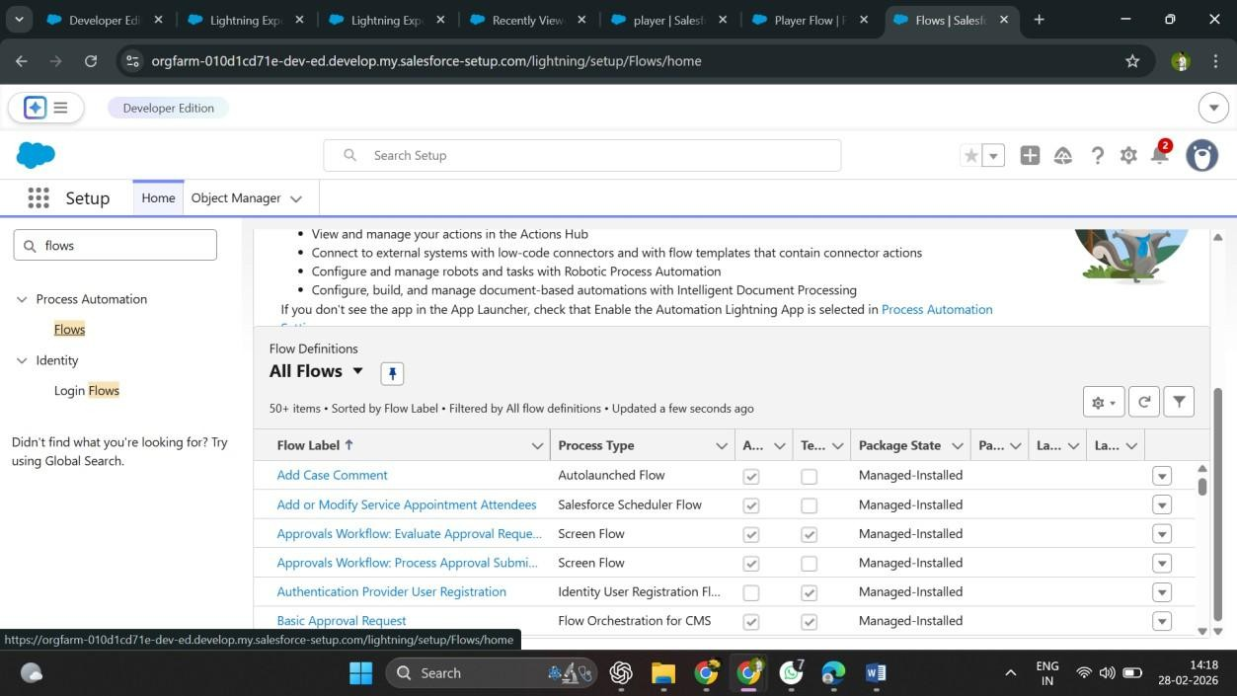

- Select Screen Flow and click Create.
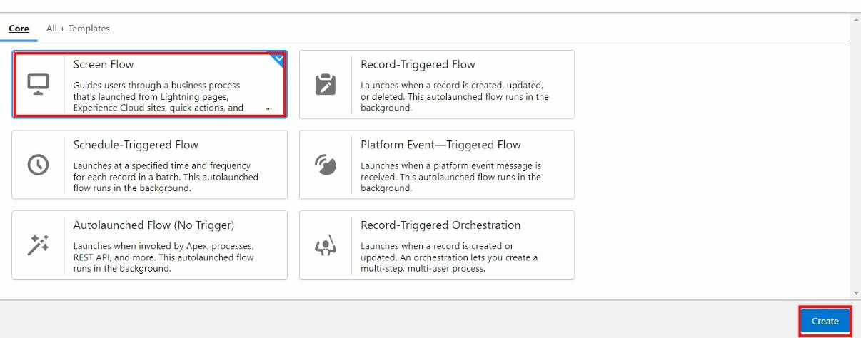

Steps to Configure Screen Component in Flow

Step 1: Add Screen Element
Open Flow Builder and click the (+) icon to add a new element.

Select the Screen component to create a user input screen within the flow.

Step 2: Configure Screen Properties
Set the following details for the screen:

- Label: Players Screen
- API Name: Players_Screen

This screen will be used to collect input from users.

Step 3: Add Picklist Component
From the left-side Component Pane, drag and drop the Picklist component onto the screen. Configure the picklist with the following details:
- Label: Team
- API Name: Team

Step 4: Configure Picklist Settings
Set the component properties as follows:

- Component Type: Picklist
- Data Type: Text

To define the available options in the picklist:

Click New Choice Resource under the Choice section to create selectable values for the Team field.

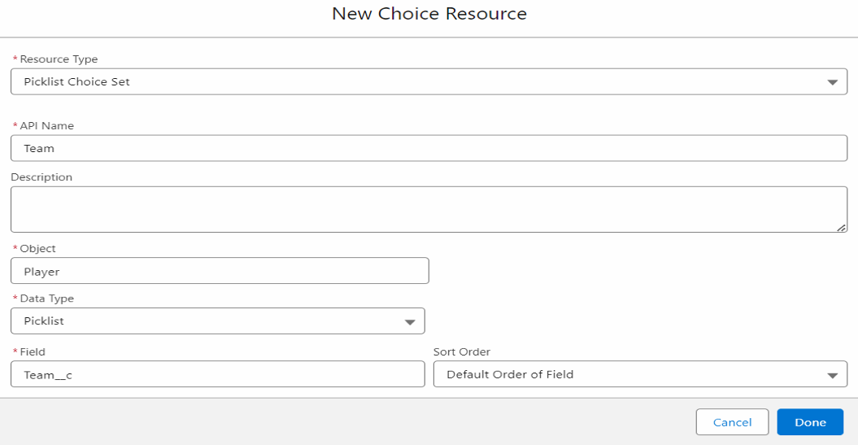

Configuring Get Records Element in Flow

Step 1: Add Get Records Element
In Flow Builder, click the (+) icon to add a new element.

Select the Get Records component to retrieve data from an existing object.

Step 2: Configure Basic Details
Set the following properties:

- Label: Players
- API Name: Players
- Object: Player

This configuration allows the flow to fetch records from the Player object.

Step 3: Define Filter Conditions
To filter player records based on the selected team, configure the following condition:

- Field: Team
- Operator: Equals
- Value: Create a New Resource

Step 4: Create a New Resource (Variable)
Click New Resource and configure it as follows:

- Resource Type: Variable
- API Name: Dynamic
- Data Type: Text
- Default Value: Select the Team value from the Screen Component (Picklist)

This variable dynamically captures the team selected on the screen and uses it to filter player records.

Purpose of This Configuration
This setup ensures that:

- The flow retrieves only players belonging to the selected team
- The filtering is dynamic based on user input
- The system provides accurate and relevant data

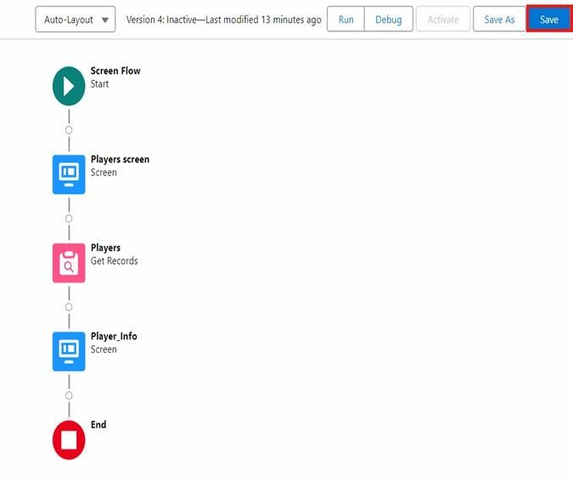

FUNCTIONAL & PERFORMANCE TESTING :

During the testing phase, screenshots were captured from the Salesforce Lightning user interface to verify the correct functioning of all implemented features in the CRICKSTATS system. These include record creation for Player and Match Performance objects; validation rule checks for mandatory fields, score limits, and input constraints; verification of record type behavior for Domestic and International match categories; and flow execution for automatic updating of player statistics and data consistency. The functionality of roll-up summary fields was also tested to ensure accurate calculation of total runs, wickets, averages, and performance metrics. In addition, system performance was evaluated by monitoring response time during data entry, report generation, and dashboard loading. The application was tested under multiple user interactions to ensure stable performance without delays. Screenshots of generated reports and interactive dashboards were documented to confirm accurate data visualization, real-time updates, and reliable performance tracking. These testing activities ensured that the CRICKSTATS platform met both functional and performance requirements and was ready for deployment.

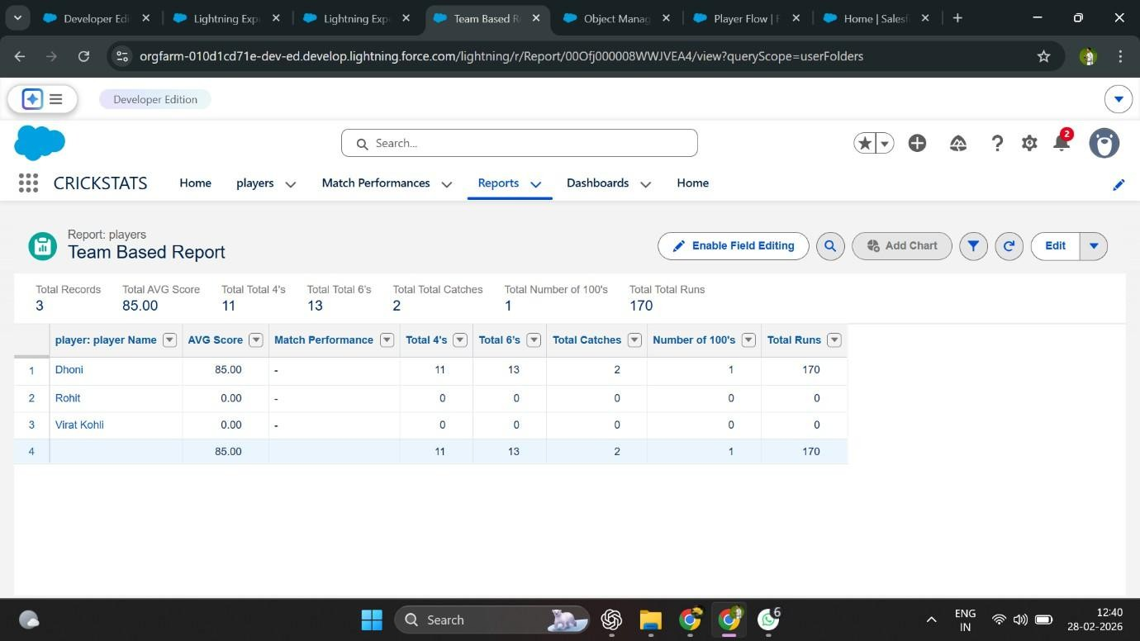

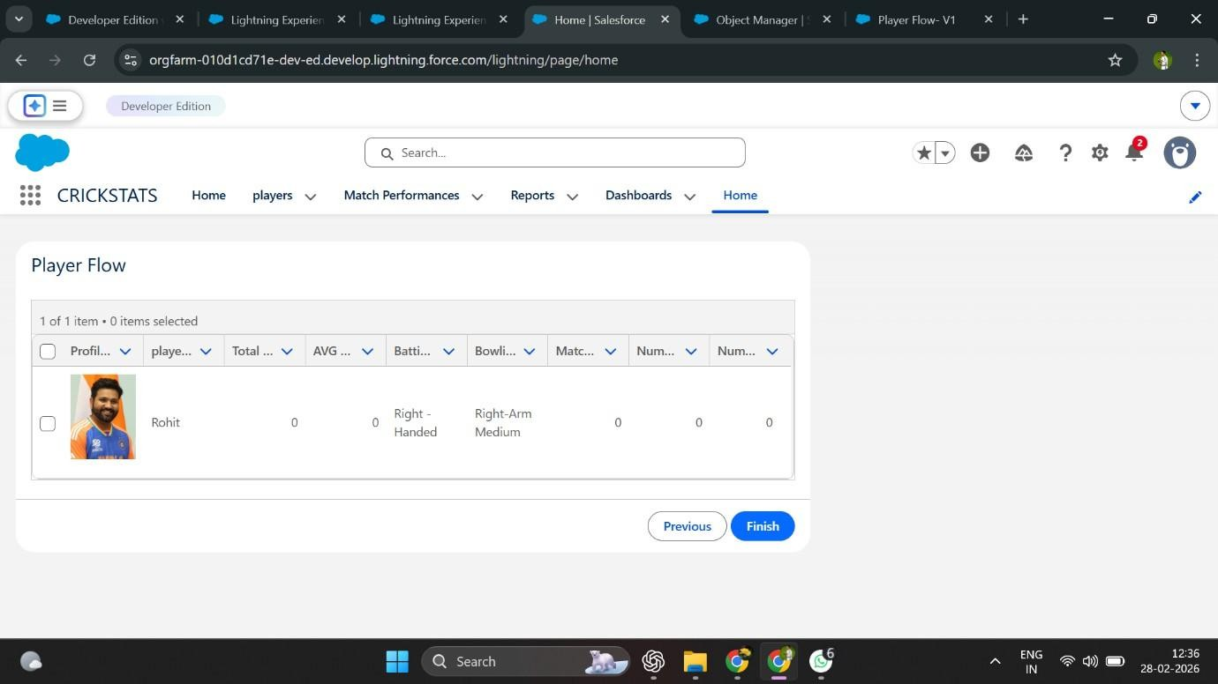

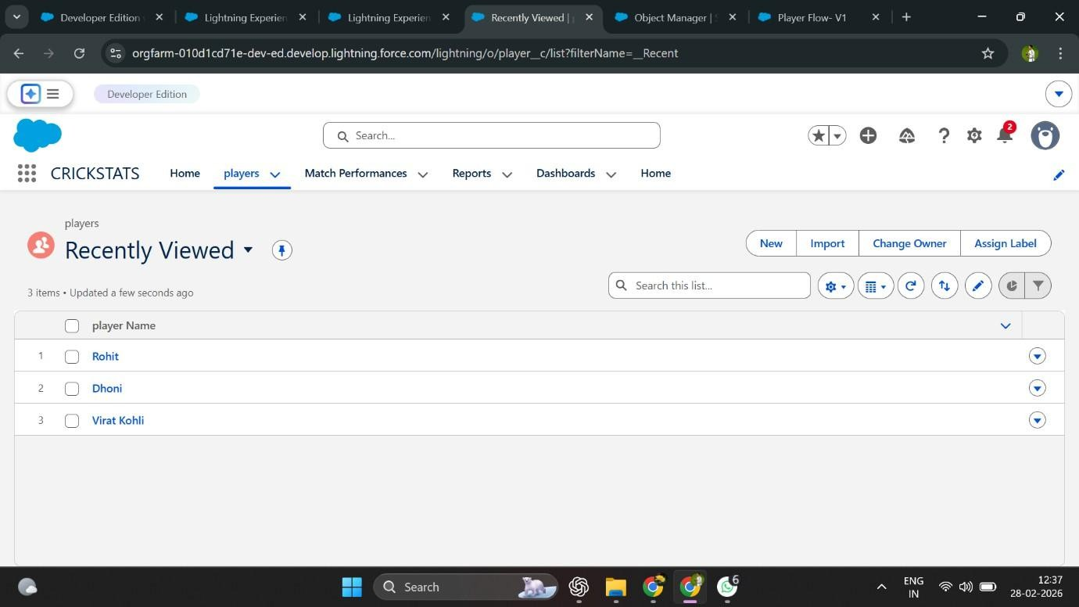

Advantages and Disadvantages

Advantages
The CRICKSTATS application provides the following advantages:

  - Centralized system for managing player and match data
  - Real-time analytics and automated calculations
  - Secure platform with role-based access control
  - Scalable cloud-based design
  - Reduced manual work and minimized human errors

Disadvantages
Despite its benefits, the system has certain limitations:

  - Requires a valid Salesforce license for full functionality
  - Dependent on internet connectivity
  - Limited offline access

Conclusion
CRICKSTATS successfully implements a cloud-based cricket performance tracking system using the Salesforce platform.

The application automates data management processes, enhances reporting accuracy, and provides structured analytical insights to support informed decision-making.

This project demonstrates the practical implementation of:

  - Software Development Life Cycle (SDLC)
  - Agile methodology
  - CRM-based application development

Overall, CRICKSTATS provides an efficient, scalable, and intelligent solution for managing cricket performance analytics.

Future Scope
The CRICKSTATS application can be further enhanced with the following features:

  - Mobile application integration
  - AI-based performance prediction
  - Video analysis integration
  - Player ranking system
  - Public statistics portal
  - Multi-league support

These enhancements would expand the system’s capabilities and improve analytical depth.

Appendix
The appendix section includes supporting materials related to the project:

  - Salesforce Objects and Fields configuration
  - Manual match statistics records
  - Flow configurations and automation logic

Thank You

